Margo Parino

Cement and Concrete Engineering

Massachusetts Standards:

1. Appropriate materials, tools, and machines enable us to solve problems, invent and construct.
2. Ideas can be communicated through engineering drawings, written reports, and pictures.
3. Identify and explain the steps of the engineering design process: identify the need, research the problem, develop possible solutions, select the best possible solution, construct a prototype, test and evaluate, communicate the solution and redesign.

Objectives:
Students will be able to identify the two components used in the formation of concrete: aggregate and cement.
Students will cure cement using different hydration materials.
Students will measure the amount of water needed to fill the voids where differing size aggregates are used.
Students will create a graph showing that multiple sized aggregates require less water to fill the void than same size aggregates.
Students will be able to identify the unit as an engineering and technology problem.

Day 1 Monday
Activate Prior Knowledge:
Review the term cementation from sedimentary rocks. What does the term cementation mean when talking about sedimentary rocks? Ask why we don’t call sedimentary rocks cementation rocks.

Lead to cementation holds the pieces of rocks together.

Procedure:
Divide the class into four groups and distribute 4
3x6 aluminum tins of Portland cement. Provide a brief history of Portland cement. Students can touch the cement or move it with a popsicle stick. Write a list of adjectives that describe the cement.
Mix the cement with the correct proportion of water. However tin one mix with 1% sugar water solution, 2nd tin 50% sea water, 3rd tin 2% mineral oil in water and 4th tin tap water. Wrap each tin with plastic wrap and let cure.

Homework: On the way home from school look at three things made from concrete. In journal write the location of the concrete, describe what they see in the slab or piece and the condition of the piece. If possible take a picture or draw. Is it cracked? Using knowledge of weathering state why they see cracks.

Day 2 Tuesday

Activate: Review Homework

Lesson: Read “Why Concrete Fails ”
Answer the questions and Web Vocabulary: Hydration, Curing and Aggregate.
Discuss why the article “Why Concrete Fails” is important: who reads it, why they would read it and how it helps.

Homework: What two steps have we completed in the Engineering Design Process?

Day 3 Wednesday Double Period
Activate:
Look at cement created. Take off plastic wrap earlier. What attributes can you give to the creations.
Which cement is the strongest/the weakest. What tests can we perform on the cement. Compare the strength of the hydration material in the cement.

Lesson:
Cement by itself is not strong enough for construction. Aggregate is held together with cement. Cement acts like a glue. What do you think you want more of glue or more aggregate?
Explain that concrete engineers look at many variables including the type of water used, size and density of aggregates, chemical stability of aggregate, aggregate shape and texture before they select the best aggregate, cement and hydration mix for the job.
The amount of cement used must be at minimum equal to the spaces in between the aggregate particles and a small amount more to make the concrete mixture relatively easy to move while pouring concrete and making the surface smooth. This is known as “workability”. What want to use a minimum amount of cement to make the concrete strong yet workable. We need to find the best aggregate to to accomplish this task.

Procedure:
Construct paper tubes that will help size differing aggregates: one inch, 3/8, and 1 ½
Have students physically separate different size aggregates into plastic containers. Label the aggregates by size.

Each of the four groups requires a 1000mL plastic beaker. Using the aggregate separated on day one choose one size and fill the beaker with that aggregate. Slowly fill the void space with water. Measure the water and record. Repeat with a different size aggregate. Using this date, hypothesize what the best aggregate to use would be. Inquiry should lead to using different size aggregates will require less water.

Create a graph where the manipulated variable is aggregate size and the responding variable is the amount of water needed to fill the void.
Homework: Essay
Review your experience with the aggregates and water. The aggregates are differing sizes to allow the most efficient surface contact between the cement and different sizes of aggregates. Why is this important?

Day 4 Thursday
Activate/Review: Ask why would you want the cement to be in contact with all sides of an aggregate.
Provide a selection of tools: What is another way you can test for the strength of your aggregate method before mixing it with cement.

Procedure:
Write up a request to build a prototype with a materials list (aggregate and hydration types and explanation. After the list and explanation is okayed construct concrete prototype in a 3X6 aluminum tin. Cover prototype with plastic.

Homework: Name two machines or devices that help people separate items by size.

Day 5 Friday
Field trip Boston Sand and Gravel

Day 5 Monday
Assessment
Using their journal and notebooks students use an outline format of the Steps of the Engineering Design Process to categorize what has taken place in the unit. Write an essay supporting your categorization.
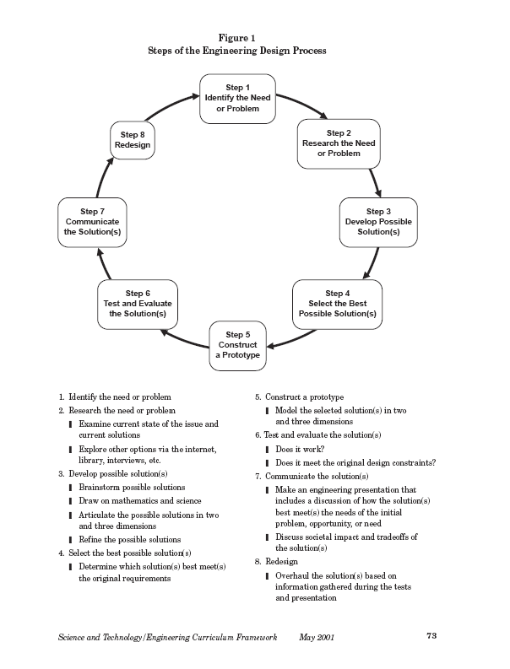

Teacher Resources:
Fundamental Facts about Concrete Chapter 1
Nicholas Pitt

